Instructor Table:

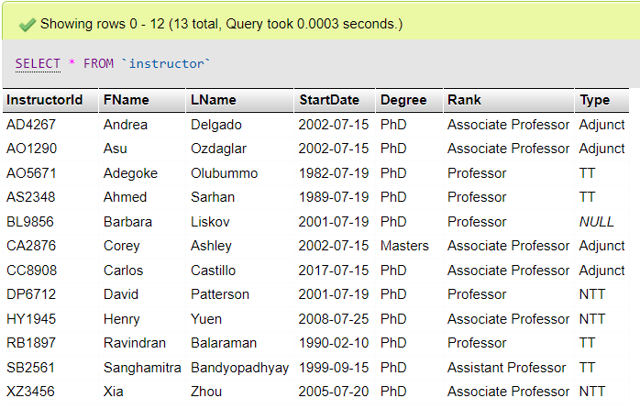

Coursetaught Table:  
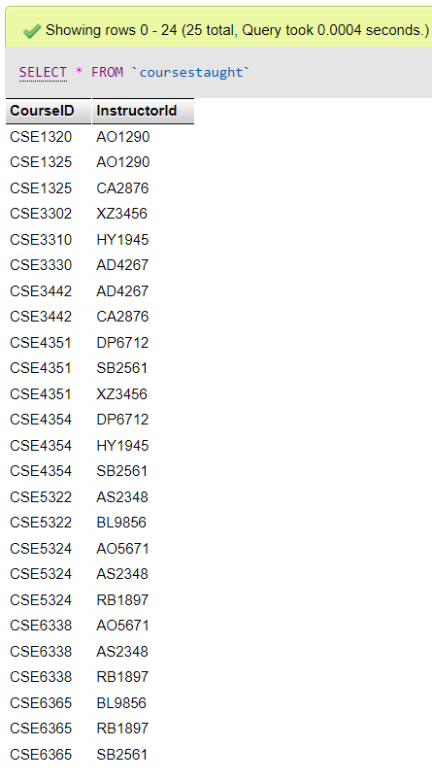

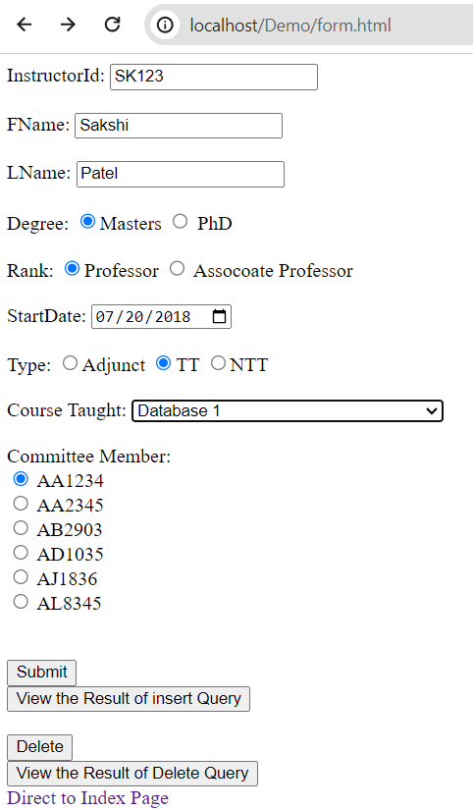

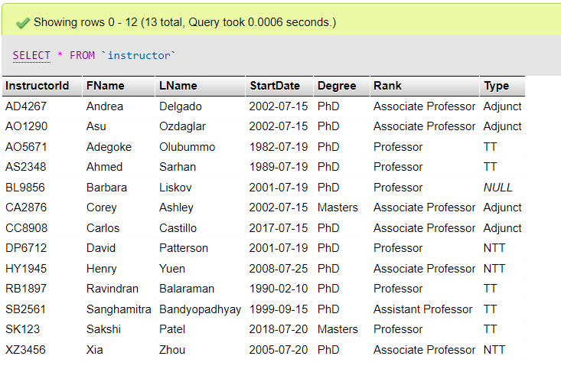

Q1. Insert a new instructor in the database. Your query should insert values for all attributes.

INSERT INTO INSTRUCTOR(InstructorId, FName, LName, StartDate, Degree, Rank, Type) VALUES ($InstructorId, $FName, $LName, $StartDate, $Degree, $Rank, $Type)  
Q2. In the Instructor table. Link the new instructor with an existing course and also add the  
instructor to a student’s committee.

INSERT INTO coursestaught (coursestaught.CourseID,coursestaught.InstructorId)VALUES($courseID,$InstructorId);

INSERT INTO phdcommittee(phdcommittee.StudentId,phdcommittee.InstructorId)VALUES($StudentId,$InstructorId);  
Q3. Delete a GRA student who has not passed any milestone yet (to avoid integrity constraint). Your query should also reflect changes in the PhD student table.  
delete from phdstudent where StudentId in(select gra.StudentId from gra where gra.StudentId not in (select DISTINCT(milestonespassed.StudentId) from milestonespassed));

delete from gra where StudentId in(select gra.StudentId from gra where gra.StudentId not in (select DISTINCT(milestonespassed.StudentId) from milestonespassed));

//[A]select phdstudent.StudentId,phdstudent.FName,phdstudent.LName,gra.MajaorResearchArea from phdstudent,gra WHERE phdstudent.StudentId=gra.StudentId;

//[B]select phdstudent.FName,phdstudent.LName,gra.MajaorResearchArea from phdstudent,gra where phdstudent.StudentId=gra.StudentId and fname='John' and lname='Doe';

//[C]select phdstudent.FName, phdstudent.LName,gra.MajaorResearchArea from phdstudent,gra where phdstudent.StudentId=gra.StudentId and (gra.MajaorResearchArea='Cyber' or gra.MajaorResearchArea='AI');

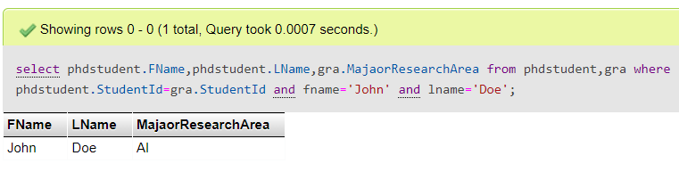

CREATE VIEW STUDENT_RESEARCH_INFO(StId, StFName, StLName, ResearchArea) AS SELECT PHDSTUDENT.StudentId, PHDSTUDENT.FName, PHDSTUDENT.LName, GRA.MajaorResearchArea FROM PHDSTUDENT, GRA WHERE phdstudent.StudentId=GRA.StudentId;